**SRI RANGAPOOPATHI COLLEGE OF**

**ENGINEERING**



A CRM Application to Manage the Mall

**SUBMITTED**

**BY:**

## M. BALAGURUNATHAN

**V.CHANDRU**

## S.KARTHICK

## S. DHATCHANAMOORTHI

**TABLE OF CONTENT**

|  |  |  |
| --- | --- | --- |
| **S.NO** | **TITLE** | **PAGE NO** |
| **1.** | **Introduction** |  |
| **2.** | **Project Overview** |  |
| **3.** | **Objectives** |  |
| **4.** | **Features and Functionality** |  |
| **5.** | **Design a CRM Application** |  |
| **6.** | **Testing and Validation** |  |
| **7.** | **Key Scenarios** |  |
| **8.** | **Benefits** |  |
| **9.** | **Project Images** |  |
| **10.** | **Github Repository** |  |
| **11.** | **Conclusion** |  |

A CRM Application to Manage the Mall

## PROJECT OVERVIEW:

The **MallMate CRM** is designed to simplify the management of shopping malls by providing a centralized platform to handle tenants, visitors, events, and maintenance. It streamlines tenant management by storing lease agreements, tracking rental payments, and managing renewals. The application enhances visitor engagement through loyalty programs, personalized promotions, and event notifications, improving customer satisfaction. Event scheduling and space allocation are made easier, enabling the mall to host activities efficiently. [Additionally, the CRM includes tools for logging and tracking maintenance requests, ensuring quick resolution by assigning tasks to staff or contractors].

## OBJECTIVES:

* 1. **Streamline Tenant Management**
     + Maintain detailed tenant profiles, including lease agreements and contact information.
     + Automate rent collection, payment tracking, and lease renewal processes.

## Enhance Visitor Experience

* + - Implement loyalty programs and personalized promotions.
    - Provide real-time updates on offers, events, and mall activities.

## Optimize Event and Space Management

* + - Simplify scheduling and coordination of events and promotional activities.
    - Efficiently allocate and manage shared spaces for temporary vendors or exhibitions.

## Improve Maintenance and Issue Resolution

* + - Enable logging and tracking of maintenance requests.
    - Assign and monitor tasks to ensure timely resolution.

## Centralize Data and Analytics

* + - Offer comprehensive insights into mall performance, including footfall, sales, and tenant satisfaction.
    - Support data-driven decision-making for improved operational efficiency.

## Enhance Communication and Collaboration

* + - Facilitate seamless communication between mall management, tenants, and visitors.
    - Provide a single platform to manage inquiries, complaints, and updates.

## Boost Revenue and Retention

* + - Strengthen relationships with tenants and customers through better service and engagement.
    - Use data insights to create targeted strategies for revenue growth.

***Business Goals:***

## Enhance Operational Efficiency:

Streamline workflows for managing tenants, events, and maintenance to reduce manual effort and improve productivity.

## Increase Tenant Satisfaction and Retention:

Provide seamless communication and support to tenants, ensuring timely resolution of issues and long-term partnerships.

## Boost Customer Engagement:

Offer personalized promotions, loyalty programs, and event updates to attract and retain visitors, increasing mall footfall.

## Improve Revenue Growth:

Optimize space utilization, manage leases effectively, and leverage data insights to drive higher revenue.

## Data-Driven Decision Making:

Use real-time analytics to make informed decisions about mall operations, marketing strategies, and tenant management.

***Specific Outcomes:***

# Tenant Management Success:

* + Reduce delays in rent collection by 30% through automated reminders.
  + Achieve a 20% improvement in tenant retention rates within the first year.

# Customer Loyalty and Footfall:

* + Increase visitor participation in loyalty programs by 25%.
  + Boost mall footfall during events by 15% through targeted promotions.

# Event Efficiency:

* + Reduce time spent on event planning and coordination by 40%.
  + Increase revenue from short-term space rentals by 10%.

# Maintenance Optimization:

* + Resolve 95% of maintenance requests within the SLA timeframe.
  + Lower overall maintenance downtime by 20%.

# Insight-Driven Growth:

* + Generate monthly reports on tenant sales and visitor trends, leading to actionable strategies.
  + Identify and fill underperforming mall spaces, improving occupancy by 10%.

## 3. SALESFORCE KEY FEATURES AND CONCEPTS UTILIZED FOR MALL MANAGEMENT CRM.

1. ***Tenant and Lease Management***

## Accounts and Contacts:

Manage detailed profiles for tenants (accounts) and their key personnel.

## Custom Objects and Fields:

Track lease agreements, rental payments, and renewal dates with tailored data models.

1. ***Visitor Engagement and Loyalty Programs***

## Marketing Cloud:

Send personalized promotions, event invites, and loyalty updates via email, SMS, or social media.

## Customer Journeys:

Automate visitor engagement processes, from sign-ups to feedback collection.

1. ***Event and Space Management***

## Salesforce Scheduler:

Manage bookings for event spaces, pop-ups, or promotions.

## Calendar Integration:

Enable seamless scheduling and visibility of mall events.

1. ***Maintenance and Service Requests***

## Service Cloud:

Log, assign, and track maintenance requests for mall facilities.

## Case Management:

Monitor issue resolution times and ensure SLA compliance for repairs or cleaning.

1. ***Reporting and Analytics***

## Salesforce Reports and Dashboards:

Generate real-time insights on footfall, sales, tenant performance, and event outcomes.

## Einstein Analytics (Tableau):

Use AI-powered tools to forecast trends and optimize mall operations.

1. ***Communication and Collaboration***

## Chatter:

Facilitate communication between mall management, tenants, and staff.

## Email-to-Case:

Convert tenant or visitor emails into support tickets for streamlined issue handling.

1. ***Automation and Workflows***

## Flow Builder:

Automate repetitive tasks like rent reminders, maintenance requests, and follow-ups.

## Process Builder:

Trigger automated actions for tenant onboarding or lease renewals.

1. ***Security and Scalability***

## Role-Based Access Control (RBAC):

Ensure secure data access by defining roles for mall staff, management, and tenants.

## Scalability:

Accommodate growing tenant and visitor data as the mall expands its operations.

1. ***Mobile Accessibility***

## Salesforce Mobile App:

Allow mall management and staff to access CRM features on the go for quick updates and task completion.

1. ***AppExchange Integrations***
   * Integrate with third-party applications for POS systems, visitor tracking, or loyalty program enhancements.

## DETAILED STEPS TO SOLUTION DESIGN A CRM APPLICATION FOR MALL MANAGEMENT.

***Step 1: Requirement Gathering and Analysis***

## Identify Stakeholders:

Mall management, tenants, visitors, maintenance teams, and IT support.

## Understand Business Needs:

Gather inputs on pain points and expectations, such as tenant management, event coordination, visitor engagement, and analytics.

## Define Use Cases:

Document specific scenarios like tenant onboarding, rent tracking, event booking, and loyalty program management.

## Set Key Performance Indicators (KPIs):

E.g., tenant retention rate, event participation, maintenance resolution time, etc.

***Step 2: Define the Solution Architecture***

## Choose CRM Platform:

Select Salesforce or another CRM tool based on scalability, customization, and integration needs.

## Plan Data Architecture:

* + - Define entities (e.g., tenants, visitors, events, spaces).
    - Establish relationships (e.g., tenants linked to leases, visitors linked to loyalty programs).
    - Create a data model with custom objects and fields for mall- specific needs.

***Step 3: Map Features to Business Needs***

## Tenant Management:

Use Accounts, Contacts, and custom Lease objects to manage tenant profiles and lease agreements.

## Visitor Engagement:

Configure Marketing Cloud to send personalized promotions and manage loyalty programs.

## Event Coordination:

Implement Salesforce Scheduler and calendar integration for booking spaces and managing events.

## Maintenance Requests:

Leverage Service Cloud to log, assign, and track facility-related issues.

## Analytics:

Use Salesforce Reports and Dashboards or Tableau for insights into performance metrics.

***Step 4: Design Workflows and Automation***

## Process Automation:

* + - Use Flow Builder to automate lease renewal reminders and rent payment tracking.
    - Set up case escalation workflows for unresolved maintenance requests.

## Engagement Journeys:

Automate visitor communications, such as loyalty updates and event invites.

## Approval Processes:

Configure for key approvals, such as space allocation and event approvals.

***Step 5: Develop and Customize***

## Customization:

Build custom objects, fields, and layouts for mall-specific needs like space allocation and promotions.

## User Interface (UI):

Design an intuitive UI tailored to the roles of mall management, tenants, and staff.

## Integration:

* + - Integrate with third-party systems (e.g., visitor tracking, POS, or accounting software).
    - Ensure seamless data flow with APIs.

***Step 6: Implement Security Measures***

## Role-Based Access Control (RBAC):

Define access levels for various user roles (e.g., admin, tenant, visitor).

## Data Security:

Ensure secure handling of sensitive data through encryption and compliance with GDPR or other local regulations.

***Step 7: Testing and Validation***

## Unit Testing:

Validate individual features like rent tracking, event booking, or visitor notifications.

## Integration Testing:

Ensure smooth data exchange between CRM and external systems.

## User Acceptance Testing (UAT):

Collect feedback from stakeholders to refine features.

***Step 8: Deployment and Training***

## Deployment:

Roll out the application in phases, starting with core functionalities.

## Training:

Conduct role-based training sessions for mall management, staff, and tenants.

## Support Plan:

Set up a helpdesk or support system for on going assistance.

***Step 9: Monitor and Optimize***

## Performance Monitoring:

Track KPIs to assess the system’s impact on operations.

## Feedback Loop:

Collect feedback from users to identify areas for improvement.

## Continuous Updates:

Add new features or enhancements based on evolving needs.

## TESTING AND VALIDATION IN A CRM APPLICATION TO MANAGE THE MALL.

1. **Understanding CRM Requirements**

Before testing, ensure all features of the CRM application are well- documented, such as:

* + Customer data management.
  + Loyalty programs and rewards tracking.
  + Tenant and service management.
  + Marketing campaign tools.
  + Real-time analytics for footfall, sales, and trends.

## Types of Testing and Validation

1. ***Functional Testing***
   * **Objective**: Ensure all features function as expected.

## Key Scenarios:

* + - Add, update, and delete customer profiles.
    - Manage tenant contracts and billing.
    - Track rewards and loyalty points accurately.
    - Execute marketing campaigns (e.g., sending emails or SMS).
    - Generate accurate reports and dashboards.

1. ***Usability Testing***
   * **Objective**: Ensure the interface is user-friendly.

## Key Scenarios:

* + - Validate navigation between modules.
    - Test the ease of form inputs for adding tenant/customer details.
    - Ensure intuitive layout for dashboards.

1. ***Performance Testing***
   * **Objective**: Test how the application performs under load.

## Key Scenarios:

* + - Simulate multiple users accessing the system simultaneously.
    - Analyze response times for database-heavy operations (e.g., fetching analytics).
    - Evaluate downtime during peak hours (e.g., holiday shopping season).

1. ***Integration Testing***
   * **Objective**: Verify that integrated systems function cohesively.

## Key Scenarios:

* + - Test integration with payment gateways for tenant billing.
    - Validate connections to third-party marketing platforms.
    - Ensure synchronization with loyalty point systems.

1. ***Security Testing***
   * **Objective**: Protect sensitive data and ensure secure operations.

## Key Scenarios:

* + - Verify encrypted storage of customer and tenant data.
    - Test user authentication and authorization levels.
    - Check for vulnerabilities like SQL injection, XSS, and CSRF.

1. ***Data Validation***
   * **Objective**: Ensure data integrity and accuracy.

## Key Scenarios:

* + - Validate customer details (e.g., phone, email, preferences).
    - Check tenant records and payment histories.
    - Audit reports for errors in analytics.

1. ***Regression Testing***
   * **Objective**: Ensure new updates don’t break existing functionality.

## Key Scenarios:

* + - Retest loyalty programs after marketing module updates.
    - Validate tenant billing after updating CRM analytics.

1. ***Mobile and Device Testing***
   * **Objective**: Ensure compatibility across devices.

## Key Scenarios:

* + - Test the application on various screen sizes and operating systems.
    - Ensure features like push notifications work on mobile platforms.

## Automation in Testing

* + **Tools**: Selenium, Appium, JMeter, etc., can be used for automation.

## Focus Areas:

* + - Automated functional tests for repetitive actions.
    - Load testing for performance under stress.
    - Regression suites for ongoing updates.

## Validation Approach

1. ***User Acceptance Testing (UAT)***
   * Conduct UAT sessions with mall administrators and tenants to validate real-world functionality.
   * Collect feedback on workflows, reports, and usability.
2. ***Data Validation with Real Scenarios***
   * Use anonymized real customer and tenant data for testing.
   * Cross-check reports against expected business metrics.
3. ***Compliance Checks***
   * Validate against legal standards, such as GDPR for customer data protection.
   * Ensure adherence to financial regulations for tenant billing.

## Documentation and Reporting

* + Maintain logs of test cases, results, and bug reports.
  + Use dashboards to present test coverage and performance metrics.

## Approach to Testing in a CRM Application

1. ***Unit Testing***
   * Focused on testing the smallest units of code, such as Apex classes and triggers, to ensure they work as expected in isolation.

**Steps for Unit Testing**

1. **Identify Test Scenarios:**
   * Validate individual Apex methods.
   * Test triggers for proper execution under various conditions.
   * Check edge cases and error-handling scenarios.

## Create Test Data:

* + Use Salesforce's TestDataFactory classes or create mock data using DML operations.
  + Ensure the test data mimics real-world scenarios (e.g., customer records, tenant data).

## Write Test Methods

* + Use Salesforce's @isTest annotation for test methods.
  + Ensure each test is independent and self-contained.

## Test Coverage

* + Aim for at least 75% code coverage, as mandated by Salesforce.
  + Focus on critical business logic and avoid unnecessary code coverage for boilerplate code.

## Assertions

* + Use System.assert and System.assertEquals methods to validate outcomes.
  + Test conditions like:
    - Successful record creation/update.
    - Trigger firing under the right circumstances.
    - Preventing invalid operations (e.g., violating business rules).

**Example Test Case**

@isTest

public class CustomerTriggerTest {

static testMethod void testCustomerCreationTrigger() {

// Setup: Create test data

Account testAccount = new Account(Name = 'Test Customer'); insert testAccount;

// Test: Verify trigger behavior

Account insertedAccount = [SELECT Id, Status c FROM Account WHERE Id

= :testAccount.Id];

System.assertEquals('Active', insertedAccount.Status c, 'Status should be Active upon creation');

}

}

1. ***User Interface (UI) Testing***
   * Ensures the front-end components of the CRM application function correctly and provide a seamless user experience.

**Steps for UI Testing**

1. **Define Test Scenarios**
   * Validate all user workflows:
     + Customer profile creation/edit.
     + Dashboard displays and navigation.
     + Submission forms for tenants.
   * Ensure all visual components render correctly.

## Prepare Test Environment

* + Use Salesforce UI Testing tools (e.g., Lightning Testing Service or third-party tools like Selenium).
  + Set up appropriate roles and permissions for testing.

## Manual Testing

* + Navigate through the UI to test:
    - Field validations (e.g., required fields, data formats).
    - Button clicks and modal dialogs.
    - Responsiveness across devices.

## Automated UI Testing

* + Use tools like Selenium or Provar for repetitive UI tests.
  + Record and replay test scripts for workflows.

## Cross-Browser and Device Testing

* + Test on popular browsers (Chrome, Firefox, Safari) and mobile devices.
  + Ensure responsive design principles are adhered to.

## Accessibility Testing

* + Validate compliance with accessibility standards like WCAG.
  + Use tools like Axe or Lighthouse to check for accessibility issues.

**Example UI Test Scenario**

**Scenario**: Testing Customer Profile Form Submission

1. **Preconditions**: User is logged in with appropriate permissions.

## Steps:

* + Navigate to "Add Customer" page.
  + Fill in all required fields with valid data.
  + Submit the form.

## Expected Result:

* + The customer profile is saved.
  + A success message appears: *"Customer added successfully."*
  + The new record appears in the customer list.

## 6. Key Scenarios Addressed by Salesforce in the Implementation Project in A CRM Application to Manage the Mall

1. **Tenant Management**
   * **Scenario**: Onboard new tenants, manage lease agreements, and track tenant performance.

## Solution:

* + - * Use Salesforce objects like Accounts and Contacts to manage tenant profiles and key personnel.
      * Custom objects for lease agreements with fields for rent details, lease duration, and renewal reminders.
      * Automated workflows to send notifications for upcoming lease renewals.

## Customer Engagement and Loyalty

* + **Scenario**: Implement and manage customer loyalty programs to increase footfall.

## Solution:

* + - * Track customer data using custom fields in Salesforce (e.g., shopping preferences, visit frequency).
      * Use **Salesforce Marketing Cloud** to design and execute personalized campaigns.
      * Integrate with a loyalty program system to reward purchases and track points.

## Marketing Campaigns

* + **Scenario**: Promote events, discounts, and offers to attract customers.

## Solution:

* + - * Use **Salesforce Pardot** or **Marketing Cloud** for campaign management.
      * Automate email and SMS notifications for promotions targeting specific customer segments.
      * Monitor campaign success metrics (e.g., email open rates, event registrations).

## Customer Support and Feedback

* + **Scenario**: Address customer issues and gather feedback for improvement.

## Solution:

* + - * Use **Salesforce Service Cloud** to manage customer service tickets.
      * Automate issue escalation workflows based on priority.
      * Integrate surveys post-resolution to collect customer feedback.

## Mall Analytics and Reporting

* + **Scenario**: Provide actionable insights for mall management.

## Solution:

* + - * Use Salesforce **Reports and Dashboards** to monitor key metrics like:
        + Daily footfall.
        + Tenant sales performance.
        + Customer engagement rates.
      * Implement **Einstein Analytics** for advanced predictive insights.

## Integration with Third-Party Systems

* + **Scenario**: Integrate Salesforce with existing mall systems like POS (Point of Sale), ERP, and loyalty systems.

## Solution:

* + - * Use Salesforce APIs and middleware (like MuleSoft) to integrate seamlessly with:
        + POS systems for sales data tracking.
        + ERP systems for billing and inventory management.
        + Loyalty platforms for point synchronization.

▪

## Space and Event Management

* + **Scenario**: Manage mall spaces for events and pop-up stores.

## Solution:

* + - * Create custom objects for space bookings with fields for dates, tenant details, and pricing.
      * Use Salesforce **Scheduler** to manage availability and allocate spaces.
      * Automate approval workflows for booking requests.

## Real-Time Notifications

* + **Scenario**: Notify stakeholders about critical events like maintenance, emergencies, or promotions.

## Solution:

* + - * Configure **Salesforce Alerts and Notifications** for real-time communication with tenants and staff.
      * Use push notifications and SMS for urgent messages, such as system downtimes or fire drills.

## Compliance and Security

* + **Scenario**: Ensure compliance with data protection regulations and safeguard sensitive information.

## Solution:

* + - * Implement Salesforce's built-in compliance tools for GDPR or other local regulations.
      * Use role-based access controls to limit data visibility to authorized personnel.

## Workforce Collaboration

* + **Scenario**: Enable seamless communication between mall management, tenants, and staff.

## Solution:

* + - * Use **Salesforce Chatter** or Slack for collaborative communication.
      * Track team tasks and milestones using Salesforce’s task management features.

## Predictive Maintenance

* + **Scenario**: Monitor and maintain infrastructure proactively to avoid disruptions.

## Solution:

* + - * Use IoT integrations with Salesforce to gather data from devices like elevators or HVAC systems.
      * Implement predictive maintenance workflows using

**Salesforce Einstein** to prevent outages.

## Visitor Personalization

* + **Scenario**: Provide personalized experiences to visitors using their preferences.

## Solution:

* + - * Leverage Salesforce **Customer 360** to consolidate data and deliver tailored offers.
      * Use geolocation tools to push targeted offers to visitors in the mall.

## Key Benefits of Addressing These Scenarios

1. **Improved tenant and customer satisfaction** through personalized experiences.
2. **Enhanced operational efficiency** via automation and streamlined workflows.
3. **Data-driven decision-making** enabled by robust analytics and reporting.
4. **Stronger customer loyalty** through targeted campaigns and rewards.

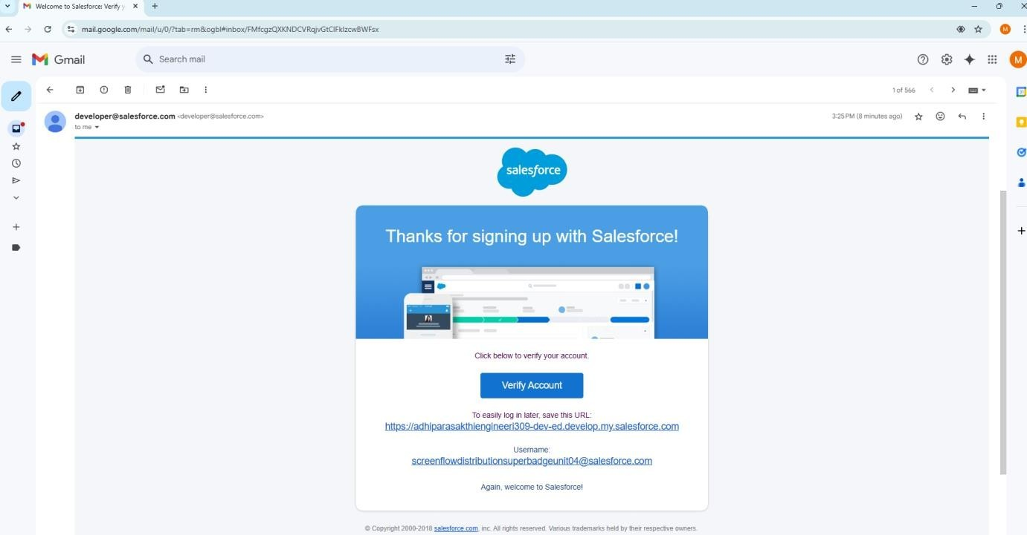

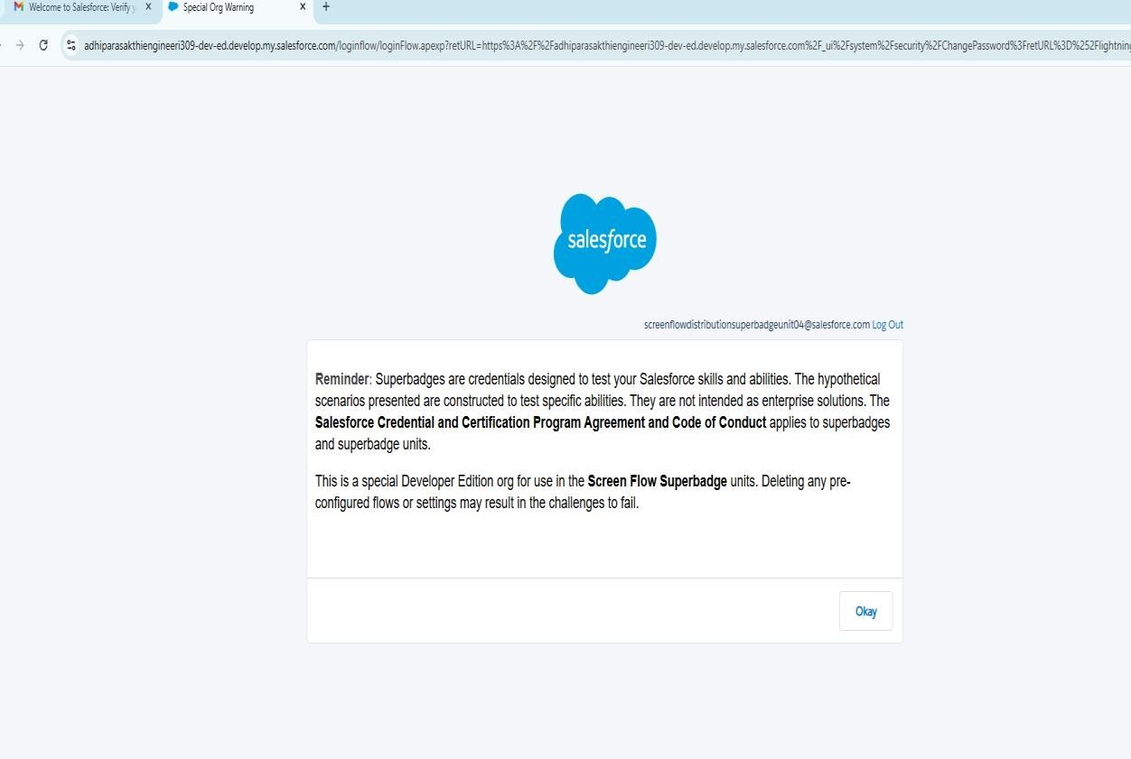

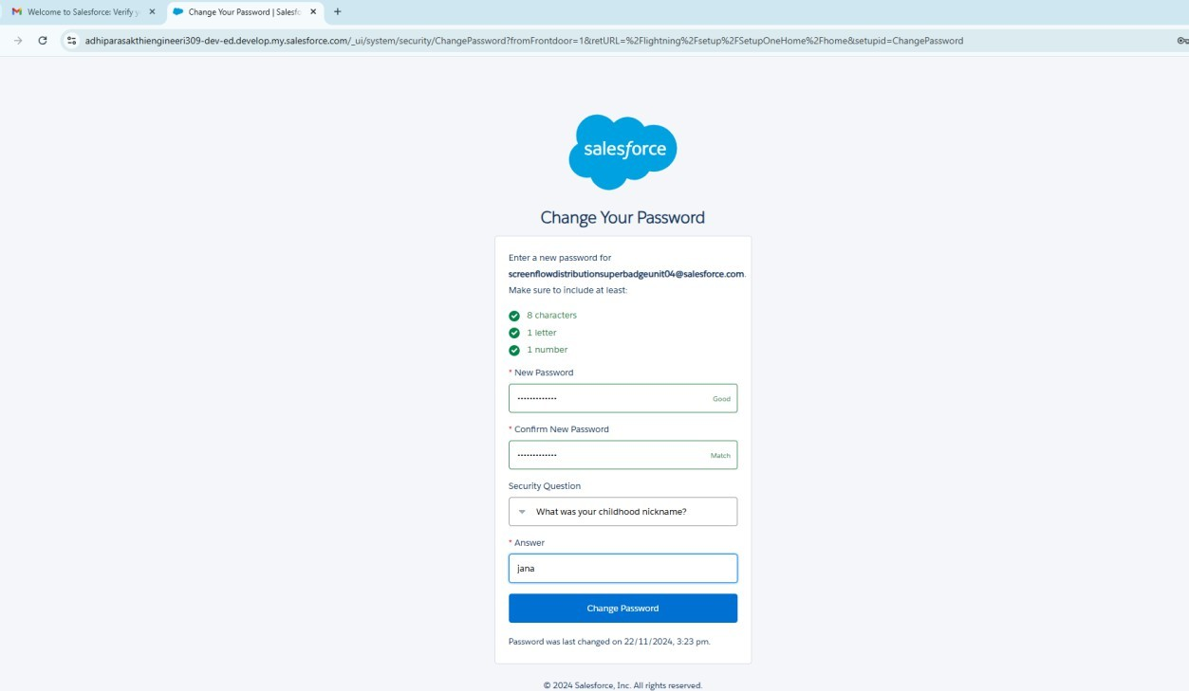

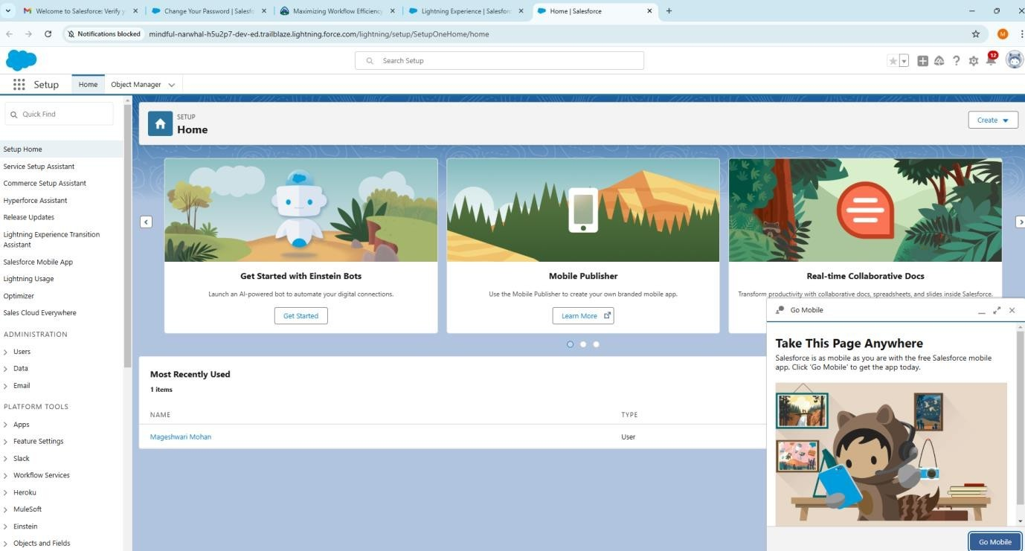

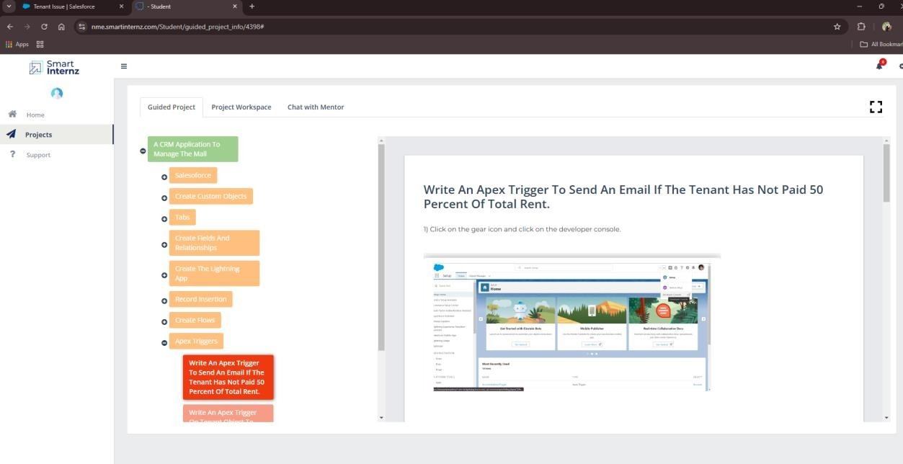

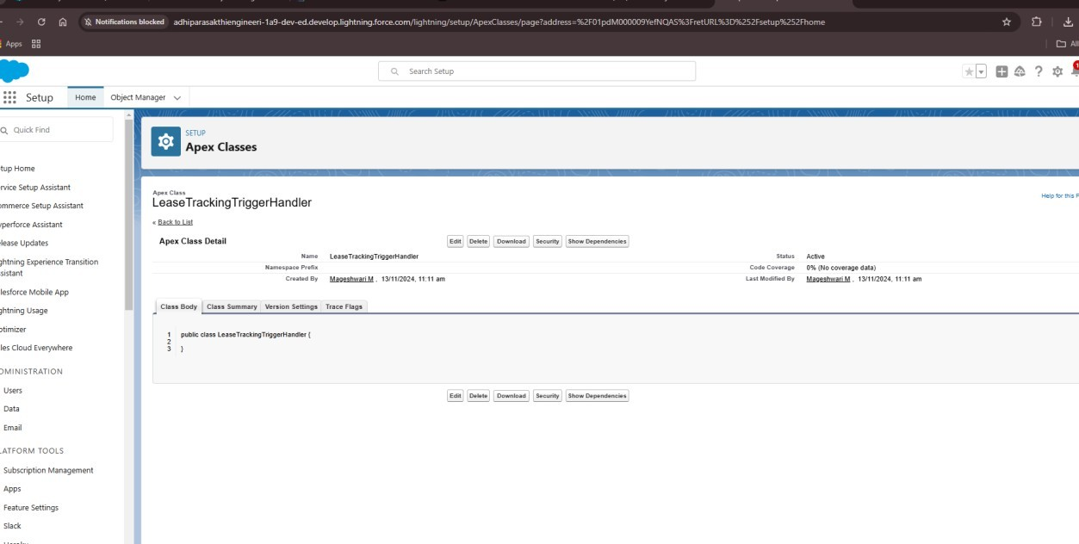

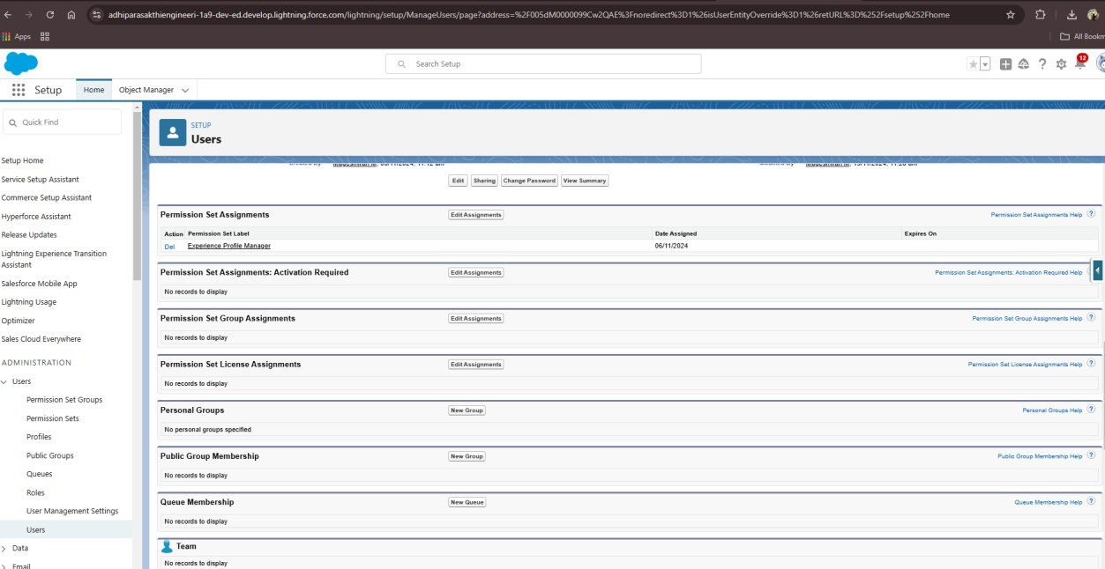

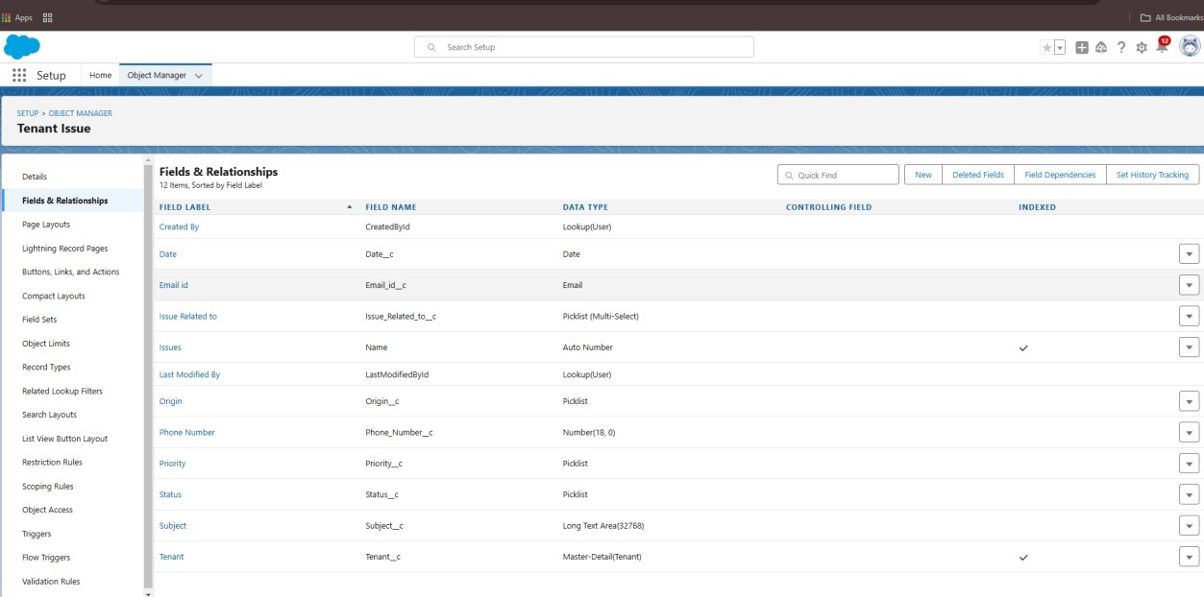

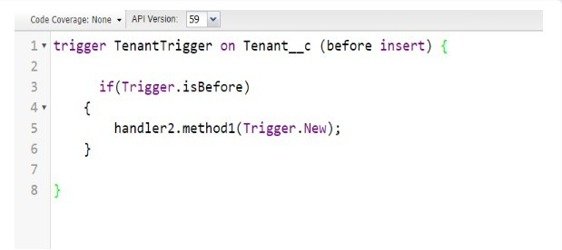

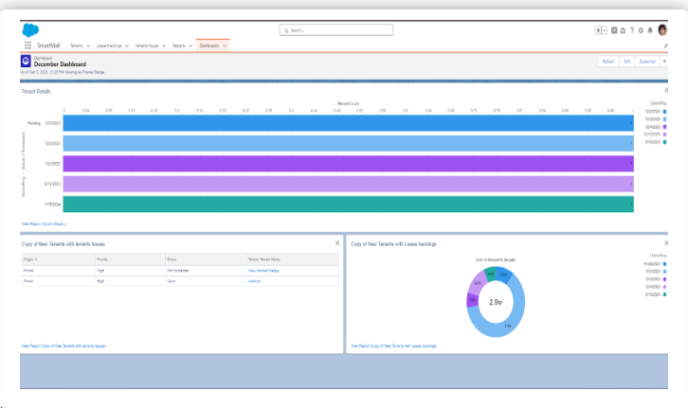

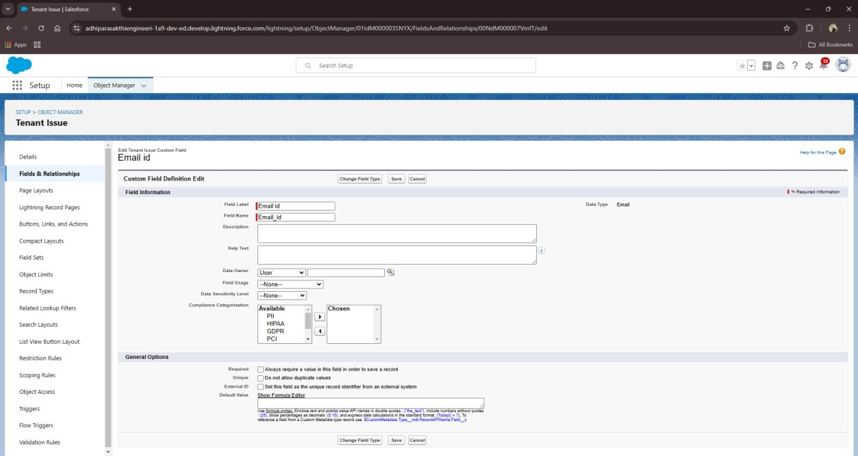

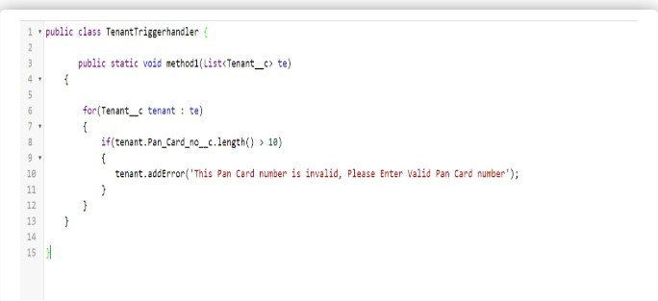

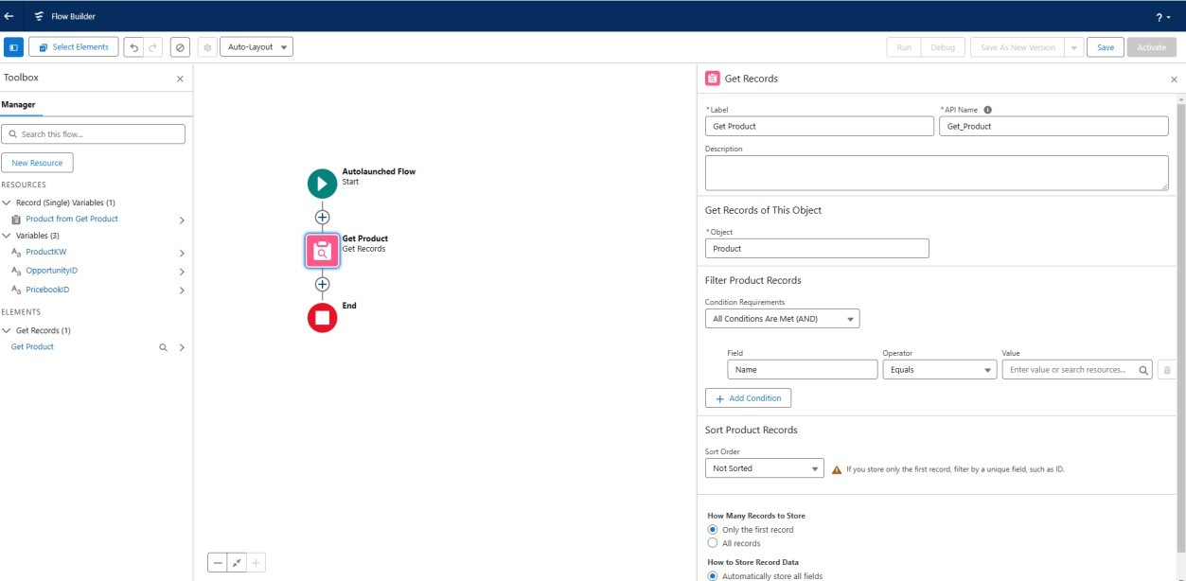

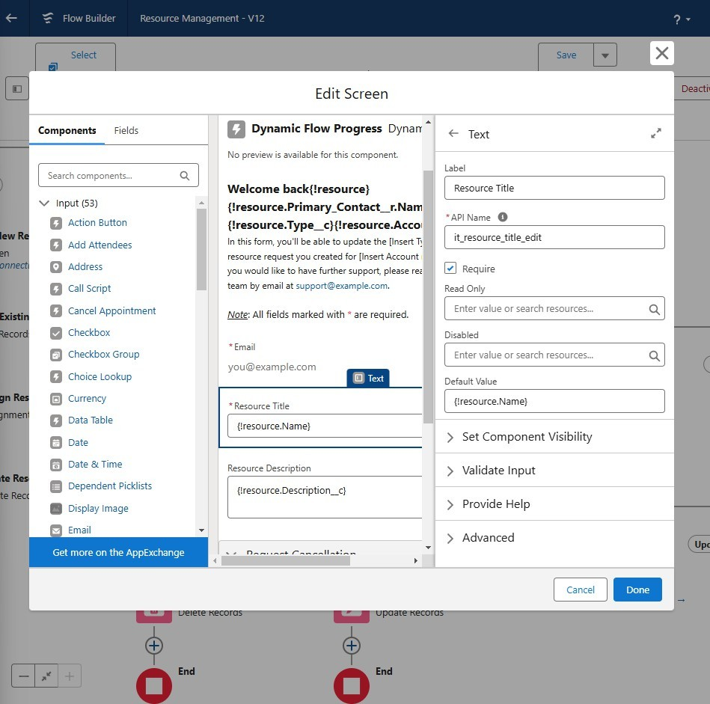

## 7. CONCLUSION Summary of Achievements:

The implementation of the CRM application for managing the mall has successfully addressed the key operational and strategic goals. Below is a brief summary of the accomplishments:

## Enhanced Tenant Management

* 1. Established a streamlined system for managing tenant profiles, lease agreements, and performance tracking.
  2. Automated reminders for lease renewals and payment follow-ups, improving operational efficiency.

## Improved Customer Engagement

* Launched a comprehensive customer loyalty program integrated with the CRM, increasing visitor retention and footfall.
* Personalized communication through targeted marketing campaigns, resulting in improved customer satisfaction and higher ROI.

## Seamless Marketing Execution

* Implemented automated workflows for email and SMS campaigns, enabling quick and effective promotion of events, offers, and discounts.
* Real-time analytics to measure campaign performance and adapt strategies for better outcomes.

## Advanced Analytics and Insights

* Provided mall management with actionable insights through dynamic dashboards and detailed reports on tenant sales, footfall trends, and customer behavior.
* Leveraged predictive analytics to identify trends and make informed decisions for future initiatives.

## Improved Customer Support

* Deployed a robust system for addressing customer inquiries and issues, leading to faster resolutions and better service quality.
* Automated feedback collection processes to continuously enhance service offerings.

## Integration and Scalability

* Successfully integrated the CRM application with third-party systems, including POS, ERP, and loyalty platforms, for a unified ecosystem.
* Designed the system for scalability, ensuring it can adapt to future business growth and new feature requirements.

## Enhanced Operational Efficiency

* Automated repetitive processes, reducing manual effort and minimizing errors.
* Centralized data storage for tenant, customer, and operational information, improving accessibility and collaboration across teams.

## Compliance and Security

* Ensured compliance with data protection regulations (e.g., GDPR), safeguarding sensitive tenant and customer data.
* Implemented role-based access controls to maintain data privacy and system security.

## Github Repository:

**Conclusion**

The CRM application has transformed the management of the mall, delivering a powerful platform for streamlining operations, enhancing tenant and customer satisfaction, and driving business growth.